Roadster Corp System Integration Project Plan
Name
Institution
Date

Roadster Corp System Integration Project Plan
Roadster Corp is a multinational car manufacturer that strives to gain competitiveness using the integration of MIS. The corporation has 15 locations across the globe with a plan to incorporate three additional branches, which aims to bolster service delivery and increase its market share. The 15 strategic locations represent five (5) regional offices, five (5) manufacturing plant units, as well as five (5) sales and marketing units. Further competition reports indicate Roadster Corp faces a protracted surge in demand for its car models, which necessitates the need to establish three additional branches to improve service delivery.
Consequently, increased expansion of the operational and strategic geographic locations elicits three fundamental effects. First, the existing 15 locations and the three (3) new branches result in detrimental congestion of the existing MIS networks. The effects of network congestion in a technology-centered multinational entity are profound because of the possibility of delays in service delivery, inadequate data processing, and glitches in the flow of vital information. Secondly, the rapid expansion of the number of network users because of the additional branches has been marred by the series of system intrusions and breaches in the last nine months. Thirdly, the current MIS network is likely to collapse because of the limited flexibility, interoperability, and scalability. The role of a Network Administrator is necessary to manage, optimize, and troubleshoot the existing enterprise-wide network.
Notably, adequate skills in project management play an essential role to optimize the efficacies of a robust MIS at Roadster Corp. The threat of potential system overload and subsequent collapse necessitate the need to develop an effective project plan. The inherent project plan for the Roadster Corp gears to provide a robust guideline in the integration of existing MIS network to the new branches and hedge against the continued manifestation of the deleterious effects. An elaborate project plan entails five elements that enhance the success rate of a system integration activity.
Project Requirements Element
The network integration project incorporates profound requirements that facilitate the Network Administrator to meet the needs of the business in addition to creating value for the stakeholders and robust solution. The identified project requirements depict a clear picture of the specifications needed to design a stable MIS that incorporate the expanding number of users and hedge against intrusions. The three identified project requirements aim to address the specific objective from three perspectives, which include the business operational excellence, maximizing stakeholders’ values, and business solutions.
First, the primary business requirement addressed in the MIS integration project relates to achieving seamless coordination of the existing servers and users applications. Roadster Corp headquarters has the largest assortment of technological devices than the rest of the strategic locations. Specifically, the headquarter boosts of 18 servers that host the rest of the enterprise-wide applications including the mail, Enterprise Resource Planning (ERP) system, and the Database Management Systems (DMS). Conversely, each of the 15 locations has been allocated ten (10) servers, 15 desktops processors, and 12 EPSON Printers to harness the communication efficiency.
Secondly, the success of the MIS integration project hinges on the ability to create sustainable value for the stakeholders. A project stakeholder refers to an individual or entity with valid interests in the product that an organization provides. The need for a particular stakeholder is unique, which necessitate the need for the Network Administrator to achieve a balance in the course of project delivery. The cadre of the stakeholders for the inherent MIS integration project is the internal users in the 15 locations and the proposed three (3) branches. The internal users require a stable, secure, and reliable Local Area Network (LAN) connectivity to optimize the organization’s Information System (IS) network. Specifically, the entire strategic locations for the Roadster Corp are to be connected via CISCO Routers to harness the level of interoperability and scalability of the MIS network. Each location requires the provision of a compatible Network Switch to create the desired LAN. Therefore, the Network Administrator needs to procure compatible nodes and CISCO switches for the 15 locations with an objective to improve and expand the existing network.
Lastly, an integral project requirement focuses on creating sufficient business solutions. Therefore, the Network Administrator has an obligation to design an IS network that supports future expansion and secures the critical input against intrusion. Consequently, Roadster Corp desires to have the existing ERP application, Database Management System, and Mail capabilities operate on an integrated IS network. Notably, the Network Administrator has a fiduciary duty to ensure the running of the ERP application incorporates the variations in the locations of the branches. Roadster Corp is a multinational entity that has a location in different geographical regions across the globe, which exposes the company to different cultural dimensions among the various calibers of the internal stakeholders. Importantly, the three project requirements play an integral role because of the ability to align the project’s resources with corporate objectives.
Resources Planning Element
(a). Human Resource Planning
Resources Allocation Plan is a critical competency that facilitates a project manager or Network Administrator to achieve adequate tradeoff of the scare resources. The Resource Allocation Plan merits in project management because it determines the type of resources and timing of the need, which further improves the reliability of a project schedule (Doraiswamy & Shiv, 2012). The three pertinent resources necessary to deliver the project deliverables include human, capital, and material goods. The human resources are strategic because they represent the individuals and teams tasked to undertake the entire activities. The MIS integration project hinges on functional teams to capitalize on the existing sets of skills, abilities, and knowledge. Table 1 below represents the human resource register of the personnel privy to implementation of MIS integration project.
Table 1: Human Resource Register
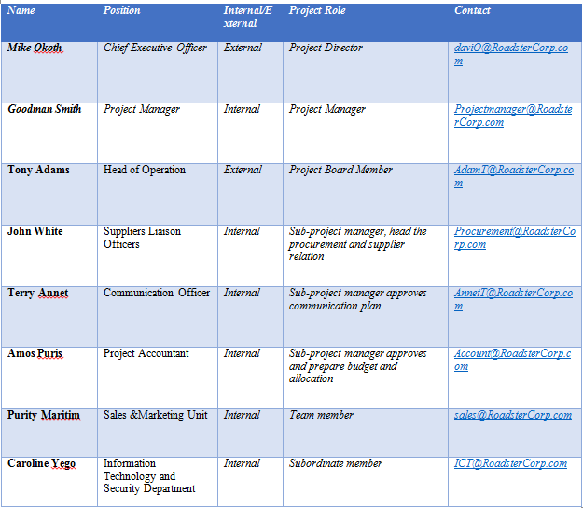
(b). Material-Assets Plan
Similarly, a Resources Allocation Plan focuses on availing necessary material goods, which constitutes a large portion of the capital resources. Planning for the material goods needed in an IT project merits because of the ability to save on cost, eradicate delays, and achieve value for the investment. The pertinent capital goods necessary for the MIS integration project for the Roadster Corp are listed in table 2 below.
Table 2: Material Allocation Plan
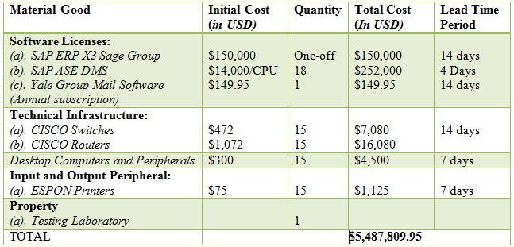
Budget Plan
Budget Plan is another essential element that influences the success of MIS integration project because it facilitates mobilization of financial resources and offset the obligations. A project budget depicts the allocation of money to the core activities. Further, Network Administrator requires adequate budgeting skills to establish the cost for each milestone and link the Resource Allocation Plan. The MIS integration project has a projected budget of $5,488,741. The five activities that have been allocated the budget include database development, material cost, and development of an integrated GUI Interface. Table 3 below identifies the upfront costs associated with six activities inherent in the MIS integration project.
Table 3: Budgetary Allocation Plan
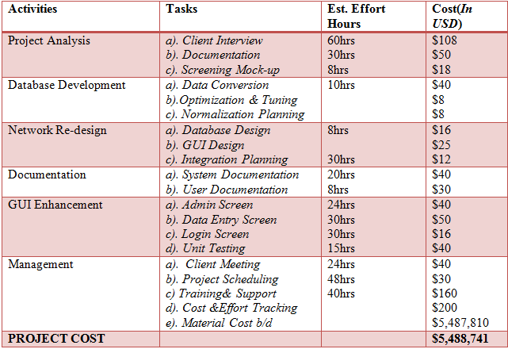
Key Project Milestones
A project milestone represents key achievements. Each milestone entails several work products that are achievable within stipulated timeframes (Doraiswamy & Shiv, 2012). The project commenced on 6 May and has an anticipated end date on 24 May 2019. The first two project milestones have been achieved before the anticipated end date. The achieved milestones include documentation of the project charter and analysis of the business requirements. The re-modeled GUI Prototype has an In-progress status and expected to have been achieved on 14, May 2019. The other milestones that have an On-hold status include System Testing and User Training Manual. Table 4 below summarizes the project milestones and the respective due date.
Table 4: Project Milestones
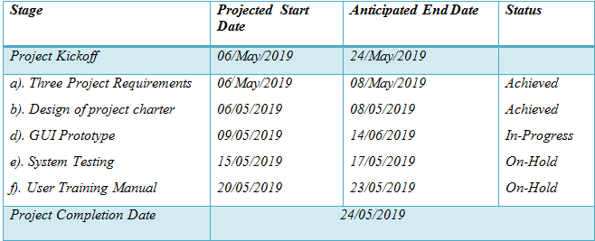
Risk Management Plan
Project management plans serve as a steering wheeling that guides a Network Administrator on how to align the core activities and resources. However, the reliability of the respective project plans hinges on the ability to predict and mitigate the detrimental effects of uncertainty during the implementation stage (Kerzner, 2012). The project identifies four approaches to handle risks that manifest during the process. First, Avoid Strategy merits because it inspires a proactive management capability to hedge against predictable risks (Loudon & Loudon, 2014). Secondly, Mitigation Strategy provides a reprieve when the manifestation of risk in inevitable because it requires the Network Administrator to take considerable actions to alleviate the effects of the project risks (ibid). Thirdly, a Transfer approach is a conventional method that necessitates a project manager to purchase an insurance cover or emphasis on performance warranty before the acquisition of respective IS peripherals and software (ibid). Lastly, Acceptance Strategy is the last resort intervention because it requires the project manager to consider certain risks as unavoidable (ibid). The adoption of a single or a combination of the multiple risk management strategy is a recommendable tactic to bolster the success of the MIS integration project.
References
Doraiswamy, P. & Shiv, P. (2012). 50 top IT project management challenges, Ely, Cambridgeshire: IT Governance Pub.
Jonasson, H. (2007). Determining project requirements: The best practices and tips, Atlanta, GA: Project Management Institute
Kerzner, H. (2012). Project management: a systems approach to planning, scheduling, and controlling, BenBella Books
Loudon, J. & Loudon, K. (2014). Management information system: Managing digital firm, (Thirteenth Edition) Boston; MA, Pearson

